Venezia Catamaran Gift Card Templates

Create your own gift card(s) using the below editable templates.
More instructions and comments at the end of this document

Template 1: Sunset Jazz Cruise for 2 persons. Value 160 Euro
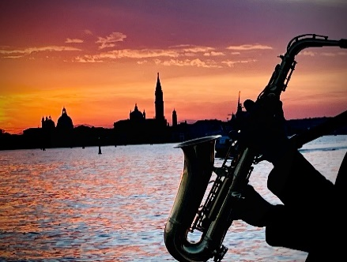
Venezia Catamaran Gift Card
Voucher No GC-xxxxxxx
Venezia Catamaran “Sunset Jazz Cruise” for 2 persons
To be converted into a valid ticket until 31/10/2025
Value 160 EUR

How to obtain your ticket
- Scan the QR Code on this voucher or go to www.venezia-cat.it
- Choose your tour, pax and date and go to Checkout
- Enter the above Voucher No. and complete the booking process

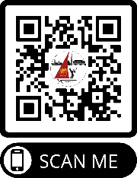

Romantic sunset over Venice
Live Jazz Saxophone
Incl. Venetian cicchetti & two drinks!

You may change any element of this voucher, just make sure to include the correct voucher No.

Template 2: Venice by Night Cruise for 2 persons. Value 120 Euro
Venezia Catamaran Gift Card
Voucher No GC-xxxxxxx
Venezia Catamaran “Venice by Night Cruise” for 2 persons
To be converted into a valid ticket until 31/10/2025

How to obtain your ticket
- Scan the QR Code on this voucher or go to www.venezia-cat.it
- Choose your tour, pax and date and go to Checkout
- Enter the above Voucher No. and complete the booking process

90 min cruise in the Venetian lagoon
on spacious and exclusive catamaran.
Live Jazz Saxophone

You may change any element of this voucher, just make sure to include the correct voucher No.

Template 3: Vivaldi Cruise for 2 persons. Value 80 Euro
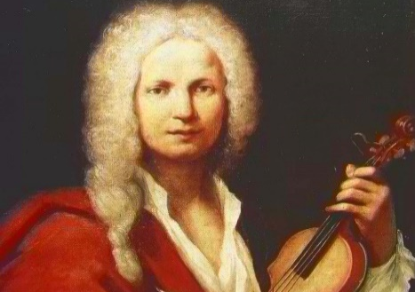
Venezia Catamaran Gift Card
Voucher No GC-xxxxxxx
Venezia Catamaran “Vivaldi Cruise” for 2 persons
To be converted into a valid ticket until 31/10/2025

How to obtain your ticket
- Scan the QR Code on this voucher or go to www.venezia-cat.it
- Choose your tour, pax and date and go to Checkout
- Enter the above Voucher No. and complete the booking process

90 min cruise in the Venetian lagoon
on spacious and exclusive catamaran to the music of Vivaldi, Bach, Chopin ...

You may change any element of this voucher, just make sure to include the correct voucher No.

Template 4: Spritz Tour for 2 persons. Value 80 Euro
Venezia Catamaran Gift Card
Voucher No GC-xxxxxxx
Venezia Catamaran “Spritz Tour” for 2 persons
To be converted into a valid ticket until 31/10/2025

How to obtain your ticket
- Scan the QR Code on this voucher or go to www.venezia-cat.it
- Choose your tour, pax and date and go to Checkout
- Enter the above Voucher No. and complete the booking process

90 min cruise in the Venetian lagoon
on spacious and exclusive catamaran.
Two free drinks included

You may change any element of this voucher, just make sure to include the correct voucher No.

Template 5: Value Voucher for 80 Euro
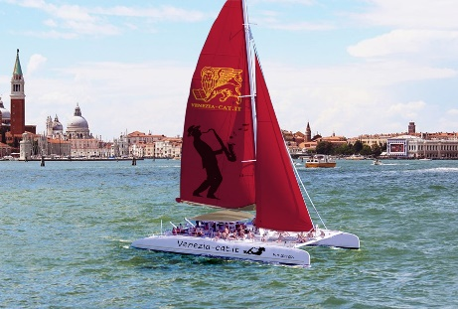
Venezia Catamaran Gift Card
Voucher No GC-xxxxxxx
Venezia Catamaran Cruises. value 80 EUR
To be converted into a valid ticket until 31/10/2025

How to obtain your ticket
- Scan the QR Code on this voucher or go to www.venezia-cat.it
- Choose your tour, pax and date and go to Checkout
- Enter the above Voucher No. and complete the booking process
- Voucher code may be used for multiple bookings

90 min cruise in the Venetian lagoon
on spacious and exclusive catamaran.
Two free drinks included

How to Use Venezia Catamaran Gift Cards

- Create Your own Gift Card Template
Based on this editable word file, create your own template. You may want to change the text, translate the voucher into other languages, or add your own company logo.
- Purchase one or more gift vouchers online
On www.venezia-cat.it/GiftCard, you buy a voucher in the value of 40, 60, or 80 Euro. After completion of the purchase, you will receive a ticket (pdf) with the gift card code, always starting with the prefix “GC-“, in the below example “GC-W3ZSX0YK”.
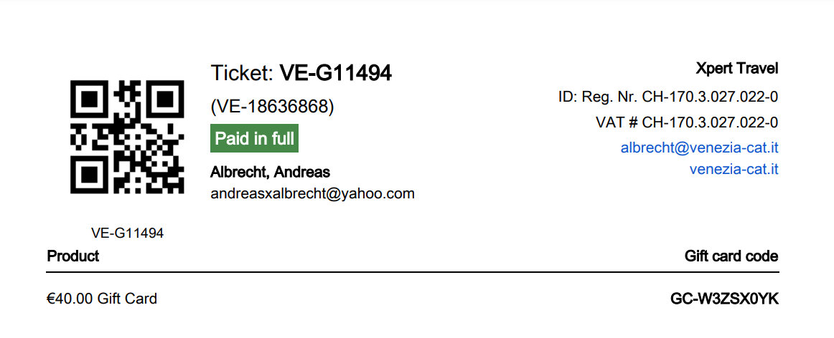
- Create your personalized Gift Card with Gift Card Code
Add the above Gift Card code to your template to create your gift card. You may also want to add the name of the person or organization that is to receive this gift card.
- Send Your Gift Card
Print your gift cards on quality paper or send them as picture via email… just make sure that your gift card contains the correct gift card code and clear instructions how to redeem the ticket.

Important Note
Whatever your choice of voucher and the wording of your gift card, our vouchers are NOT linked to any specific tour but can be used in the most flexible way for ALL Venezia catamaran products. It is also possible to use the voucher for multiple tours on different dates.
Example: A gift voucher for a Sunset Jazz Cruise in the value of 80 EUR could be used as follows:
- Buy a tickets for the Sunset Jazz Cruise
- Buy two tickets for the Spritz tour
- Buy one ticket for the SpritzTour now and another ticket for the Spritz Tour at a later date, using the same voucher code
- Buy two tickets for the Sunset Jazz Cruise, whereby one ticket is free, one ticket needs to be paid
Venice, 09 March 2024

